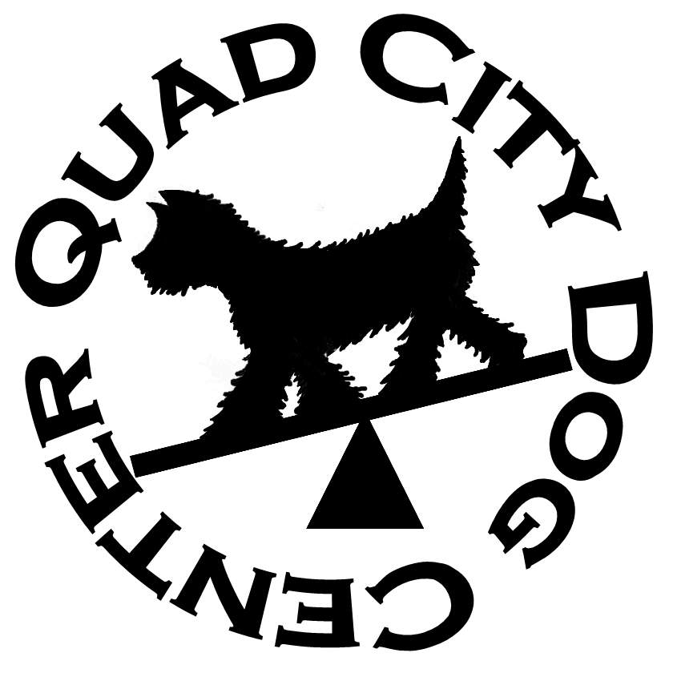Quad City Dog Center
Quad City Dog Center  October 16, 17, & 18, 2020  2390 West Lake Blvd  Davenport, Iowa  Judge: Bernie Doyle  Double Run Trial  Building and Ring Surface info:  Sport Turf  Contact Surface:  Blue/Yellow Rubberized Matting  Crating Set up times:  Friday – 4:00 PM  Saturday – 8:00 AM  Sunday – 7:00 AM  Briefing at:  Friday - 5:45 PM  Saturday – 8:45 AM  Sunday – 7:45 AM  First dog on the line at:  Friday – 6:00 PM  Saturday – 9:00 AM  Sunday – 8:00 AM | Preliminary Class Order:  May change depending on weather, judge’s preference, time or number of entries  Friday  Class: Double Run  Weavers 2  Saturday  Class: Number of Rounds:  Gamblers 2  Touch n Go 2  Chances 2  Regular 2  Sunday  Class: Number of Rounds:  Regular 2  Tunnelers 2  Jumpers 2  Barrlers 2  Give NADAC a Try…  Special promotion for handlers who have never run NADAC. $5/run for the entire weekend. Questions – email QCDCtrialsecy@gmail.com
Entries Open on:  September 12, 2020  Entries Close on:  October 12, 2020  Crating available:  Indoors on turf or concrete.  Air Conditioned.  Entry Limits:  500 Runs per day.  Move ups:  Only for Regular classes following Round 2 on Saturday for Sunday Rounds.  Day of show Entries:  DOS is offered at the trial as well as add-on runs, if space permits. No refunds will be given if DOS entry is pulled or not run.  Refunds:  Refunds after the closing date will be honored for bitches in season, or injured dogs with a $3/run administration fee. To receive the refund a written request and a letter/certification from a veterinarian must be received by the trial secretary prior to the start of judging.  No entry fee will be refunded in the event a dog and/or handler is absent, disqualified, excused, or dismissed from the competition. | Show Committee  David Bailey, Show Chair  Carolyn Venaglia, Trial Secretary  QCDCtrialsecy@gmail.com  Karen Bailey, Worker Coordinator  Deb King  Confirmations:  Confirmations will be sent by email. Please make sure your email address is legible.  Food info:  Box lunch will be available on Saturday and Sunday. Orders need to be placed by 10AM both days. Cost is $7/lunch. A vending machine with beverages and light snacks is also available.  Volunteer info:  We can’t do it without you!  There is a sign-up board at the trial for you to select when you would like to work. Workers receive a $2 credit for each class worked. Credits, up to $24, can be used at future QCDC NADAC Trial. Plus, each class you work earns a ticket in the worker raffle.  Awards and Ribbons:  All qualifying runs will receive a Purple Q ribbon. Ribbons for placements 1st through 4th are available for all classes except Chances, which is Q or NO Q only.  Rosette and Commemorative Bar for NATCH.  Equipment info:  All obstacles used the at QCDC NADAC trials meet NADAC specifications.
Jump Height Info:
MEASURING
Measurement forms may be obtained at
https://www.nadac.com/WPsite/wp-content/uploads/2019/06/HeightCardForm.pdf

Dogs which require measuring:
Dogs in the Proficient Category, Novice, Open or Elitejumping 4”, 8”, 12” or 16”

Dogs which do not need to be measured:
Dogs jumping 16” in the Veteran or Junior Handler Division
Dogs jumping 20”
Dogs in the Skilled Category
Dogs with a permanent height card
Dogs listed on the Height Exemption List
JUMP HEIGHTS
There are four Standard Division-Proficient jump heights: 8”, 12”, 16”, and 20”.
There are four Standard Division-Skilled jump heights: 4”, 8”, 12”, and 16”.
There are four jump heights for the Veterans and Junior Handler divisions: 4”, 8”, 12”, and 16”.
Please see the NADAC Rulebook for the full jump height table

Brief Summary of Rules:
Please refer to www.nadac.comfor a full explanation of all NADAC rules and up to date information.
- Please note that NADAC trials should provide a safe and fun environment for both exhibitors and their dogs.
- Aggressive dogs will not be tolerated and will be excused from the trial.
- The show committee has the right to refuse any entry. Anyone not currently in good standing with NADAC will not be allowed to enter this trial.
- Exhibitors, through submission of entry, acknowledge that they are knowledgeable of NADAC rules and regulations, and agree to abide by all rules in effect at the time of this trial.
- No entry fee will be refunded if the trial cannot open or be completed by reasons of riots, civil disturbances, fire, acts of God, public emergency, an act of a public enemy, or any other cause beyond the control of the organizing committee.
- Checks not honored by the bank do not constitute a valid entry fee. There will be a $25.00 service charge for bank returned checks.
- Dog must be registered and have a valid registration number before entries will be accepted. http://nadac.com/afrm/dogregfrm.asp A copy of the current Exhibitors Handbook may be downloaded free from the NADAC web site: www.nadac.com
- Bitches in heat, lame, or blind dogs are ineligible for entry, as is any dog with a deformity which may cause a judge to not be able to reasonably assess the dog’s ability to function and perform agility obstacles safely, and in a manner that is in the best interest, health and welfare of the dog.
- No food, clickers, or other aids or devices shall be permitted on the course or within 10 feet of the ring. Food or a small non-audible toy can be in a secure container (ziplock bag is acceptable) in your pocket during your run but it cannot be used during your run, nor can you indicate to the dog it is there. Only Intro and Novice handlers my bring a non-audible toy into the ring for training purposes. They cannot earn a Qualifying score and must declare to the judge they are training before they commence their run. Please read the Exhibitor’s Handbook for more information about toys and training in the ring.
- The sponsoring clubs will not be responsible for the loss or damage to any dog exhibited, or for the possessions of any exhibitor whether the result be accident or other cause. It is distinctly understood that every dog at this event is in the care and control of his owner or handler during the entire time the dog is on the show premises.

Quad City Dog Center Davenport, IA October 16-18, 2020
Make Checks Payable to: QCDC Pay Pal use QCDCPP@gmail.com
Send entries to: 2390 West Lake Blvd, Davenport, IA 52804 or
email to: QCDCtrialsecy@gmail.com
Owner |  |  |  |  | Dog
Name |  |  |  |  | Call Name
Address |  |  |  |  | NADAC Reg #
City/State/Zip |  |  |  |  | Date of Birth
Phone |  |  |  |  | Height at Withers
Email |  |  |  |  | Breed
Handler, If not owner |  |  |  |  | Emergency Contact Name/Phone
PLEASE INCLUDE A COPY OF YOUR DOG’S HEIGHT CARD IF YOU DO NOT HAVE ONE ON FILE.
CATEGORY: PROFICIENT SKILLED
DIVISION: JUNIOR HANDLER VET DOG VET HANDLER STANDARD
I WANT MY DOG TO JUMP: 4 8 12 16 20
Class | Level |  |  |  | Day
 | Intro | Novice | Open | Elite | Friday | Saturday | Sunday
Chances |  |  |  |  |  | Rd 1 Rd 2
Jumpers |  |  |  |  |  |  | Rd 1 Rd 2
Regular |  |  |  |  |  | Rd 1 Rd 2 | Rd 1 Rd 2
Gamblers |  |  |  |  |  | Rd 1 Rd 2
Barrelers |  |  |  |  |  |  | Rd 1 Rd 2
Hoopers
Touch n Go |  |  |  |  |  | Rd 1 Rd 2
Tunnelers |  |  |  |  |  |  | Rd 1 Rd 2
Weavers |  |  |  |  | Rd 1 Rd 2
In consideration of the acceptance of this entry, I/we certify that I/we have knowledge of, and are familiar with, and agree to abide by, the Rules and Regulations of NADAC in effect at the time of this trial, and by any additional rules and regulations as approved by NADAC for this trial. I/we certify that the dog entered is not a hazard to persons or other dogs. I/we further agree to be bound by the “Agreement” printed on page 5 of this premium

Number of Total Runs Entered (all dogs): # ___________
□ 1- 17 Runs = $12 each = ___________
□ 18 or more runs = $10 each = ___________
□ Junior Handler = $6 each = ___________
□ Day of Show (after closing) $15 each = ___________
□ Give NADAC a Try $5 each = ___________
□ Less worker card – up to $24 = ___________

TOTAL ENCLOSED =___________

Owner/Exhibitor: ____________________________________Date______________________
Parent or Legal Guardian of Junior Handler__________________________________________
AGREEMENT
The person who signs this agreement represents that he/she is authorized to enter into this agreement on
behalf of both exhibitor and the owner of entered dog. In consideration of acceptance of this entry:
1.1. As used here "NADAC" means the North American Dog Agility Council, LLC., its members, officers, directors, employees, show chairs, show committees and agents.
1.2. Exhibitor/owner agree to abide by the rules and regulations of NADAC and any other rules and
regulations appearing in the premium for this event.
1.3. Exhibitor/owner certify that the entered dog is not a hazard to persons, dogs or property and that
the entered dog's rabies vaccination is current in accordance with the requirement of the state in which the dog resides.
1.4. Exhibitor/owner acknowledge all hazards presented by the event and the event premises,
including, but not limited to, the condition of the surface, restrooms, security measures or lack of,
electrical appliances, fittings, show rings, parking areas and the presence of unfamiliar animals and
people; exhibitor and owner assume the risk of any harm arising from these.
1.5. Exhibitor/owner releases NADAC (including its respective officers, directors, employees, and
members), QCDC (including its officers, directors, members, and event organizing
committee), and QC Dog Center (including its officers, agents, and employees) and will
defend them and hold them harmless from all present and future loss, injury, damage, claims, demands
and liabilities involving the entered dog, the event or event premises. Without limiting the generality of the
foregoing hold harmless provisions, exhibitor/owner hereby specifically assumes sole responsibility for
and agrees to indemnify and save the aforementioned parties harmless from any and all loss and
expenses (including legal fees) by reason of the liability imposed by law upon any of the aforementioned
parties for damages because of bodily injuries, including death, at any time in consequence of my (our)
participation in this event, howsoever such injury or death may be caused and whether or not the same
may have been caused or may have been alleged to have been caused by negligence of the
aforementioned parties or any of their employees or agents or any other persons

QCDC Policies
THE MANAGEMENT will not be responsible for the loss or damage to any dog exhibited, or for the possessions of any exhibitor whether the result was by accident or any other cause.
1.1 All exhibitors are responsible for the behavior of their dog(s) and /or children. Any exhibitor and their dogs and/or children who engage in unsafe or disruptive behavior may, at the discretion of the Trial Committee, be asked to leave the trial site. In such case no refunds of entries will be made.
1.2 No leads, collars, food, toys, balls clickers or other aids or devices shall be permitted on the course at any time.
1.3 Dogs must be on leash anywhere on the show grounds property or in crates, when not competing in the ring. NO dogs may be tied to cars, fences, trees or other obstacles at any time.
1.4 Every owner is responsible for cleanup of waste from their dogs. Any violator will be asked to leave the trial site without refund of entry fees.
1.5 Management reserves the right to retain a 10% service charge for any cancelled entry, regardless of date or reason.

Entry Fees
Prior to Closing Date:
1-17 Runs: $12/Run 18 or more Runs: $10/Run
Junior Handler: $6/Run Give NADAC A Try: $5/Run
After Closing Date – Day of Show
All Runs $15/Run Give NADAC A Try: $5/Run
Lodging Info and Directions:
Motels That Accept Dogs*
Baymont Inn – 400 Jason Way Ct, Davenport, IA 52806, 563-386-1600 Mention the Quad City Dog Center for a special trial rate.
La Quinta Inn - 5450 27th Street Moline, IL 309-762-9008 La Quinta Inn – 3330 East Kimberly Road, Davenport, IA 563-359-3921 Country Inn and Suites Davenport- 140 East 55th Street, Davenport, IA 1-888-201-1746 Days Inn Davenport- 3202 East Kimberly Rd, Davenport, IA 563-359-7165 Super 8 Davenport – 410 East 65th Street, Davenport, IA 563-388-9810

CAMP GROUNDS That Accept Dogs*
West Lake Park- 14910 110th Avenue, Davenport, IA 563-328-3281
Interstate RV Park & Campground – 8448 North Fairmont Street, Davenport, IA 563-386-7292
Lakeside RV Park- 11325 140th Street, Davenport, IA 563-381-3413
Camelot Recreations, Inc. (KOA) – 2311 78th Ave W, Rock Island, IL 309-787-0665

*MOTELS and CAMPGROUNDS WHICH ACCEPT DOGS - Be sure and check with the motels when you make your reservations. Hotel/Motel policy is subject to change. Please check when making reservations.

Directions to Quad City Dog Center
Quad City Dog Center is conveniently located off I-280 in Davenport, Iowa, in the West Lake Industrial Park.
From the North or Northeast, take US 61 or I-88 to I-80 West. Follow I-80 West to I-280 East. Exit at Iowa Exit 4, West Locust Street. Turn right on West Locust and proceed one block to West Lake Boulevard. Turn right. Quad City Dog Center is at 2390 West Lake Boulevard, across from Honda plant.
From the East, take I-80 to I-74 to I-280 West. Follow I-280, crossing the Mississippi River. Exit at Iowa Exit 4, West Locust Street. Turn left on West Locust and proceed one block to West Lake Boulevard. Turn right. Quad City Dog Center is at 2390 West Lake Boulevard, across from Honda plant.
From the South, take I-74 West to I-280 West. Follow I-280 west, crossing the Mississippi River. Exit at Iowa Exit 4, West Locust Street. Turn left on West Locust and proceed one block to West Lake Boulevard. Turn right. Quad City Dog Center is at 2390 West Lake Boulevard, across from Honda plant.
From the West, take I-80 east to I-280, follow to Exit 4, West Locust Street. Turn right on West Locust; proceed one block to West Lake Boulevard. Turn right. Quad City Dog Center is at 2390 West Lake Boulevard, across from Honda plant.

